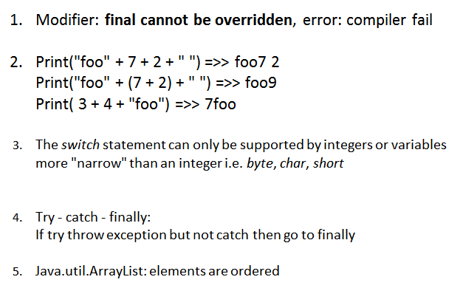

6. method local inner class ?  It can be marked abstract.

 you cannot mark any local variables as *public ?*

*7. Boolean vs boolean?*

*8. Read and Write File? Input and Output*

*I/O:*

InputStreamReader isr =new InputStreamReader(System.in);

Scanner scan = new Scanner(System.in);

int n = 10;

int a[]=new int[n];

String b[] = newString

for(int i=0; i<n; i++)

{

a[i] = scan.nextInt();

}

*9. Convert data type*

*\*\* string -> int*

*int i = Integer.ValueOf(str).intValue()*

*int i = Integer.parseInt(str)*

*\*\* Dec -> Bin/Hex*

*i=20*

String binstr = Integer.toBinaryString(i);  
String hexstr = Integer.toHexString(i);  
String hexstr = Integer.toString(i, 16)

*int i =*Integer.valueOf("B8DA3",16).intValue();

**Ascii code

A:65 - a:97 - 0:48

int -> ascii

int i = 64

char c = (char)i

ascii -> int

char a = 'A'

int = (int)a

10. Array

11. String

<http://stackoverflow.com/questions/8798403/string-is-immutable-what-exactly-is-the-meaning>

          String Str = **new** String( "Hello");

        Str.concat( " world");

        System. ***out***.println(Str ); >> Hello (String immutatble)                           StringBuilder sb = **new** StringBuilder("aaa" );

       sb.append( " bbb")

 System. ***out***.println(sb ); >> aaa bbb (StringBuilder/ StringBuffer mutable)

**String.concat**

**StringBuilder.append**

12. RegExp

String line = "abc\\sfd\\opui";

             String pattern = "(.*)\\\\([a-z]+)\\\\(.*)";

             // Create a Pattern object

             Pattern r = Pattern. *compile*(pattern);

             // Now create matcher object.

             Matcher m = r.matcher( line);

**if** (m .find( )) {

                System. ***out***.println("Found value: " + m .group(1) );

                System. ***out***.println("Found value: " + m .group(2) );

                System. ***out***.println("Found value: " + m .group(3) );

             }

**-> abc**

**-> sfd**

**-> opui**